**Use Case Diagram:**

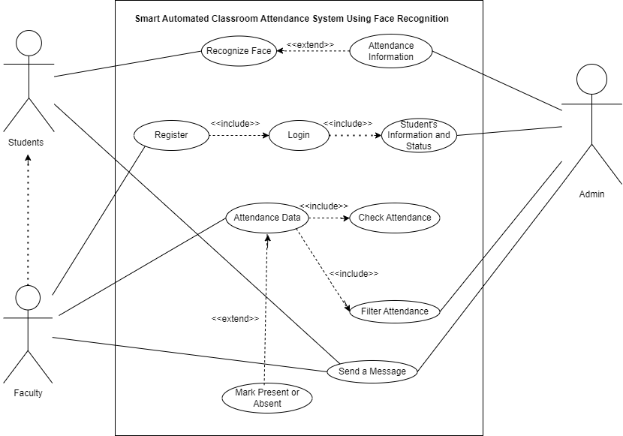

**Use Case Narratives:**

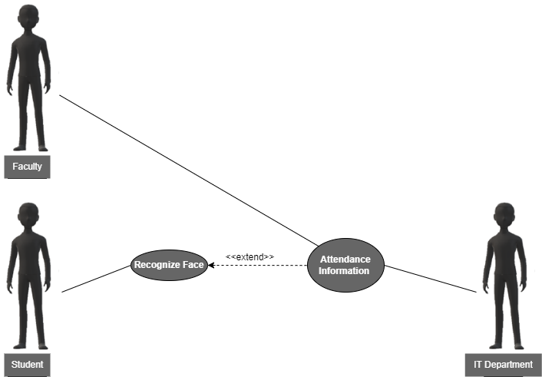

|  |  |  |
| --- | --- | --- |
| **Use Case Name:** | Automatic Attendance Marking (UC-1) | |
| **ID:** | UC-1 | |
| **Actors Involved:** | * Student * IT * Faculty | |
| **Brief Description** | It describes the automatic process of marking a student's attendance using facial recognition technology. | |
| **Pre-Conditions** | * Student registered with face image data * Classroom camera operational * Attendance system software working. | |
| **Post-Conditions** | Student attendance recorded with timestamp.  Faculty manages records. | |
| **Normal Flow of Events:** | **Actor Action** | **System Response** |
| **Student’s Action:**   1. Enters the classroom and the student does not need to take any specific actions beyond being present within the camera's view for facial recognition to occur. | 1. Face Recognition 2. Attendance Marking |

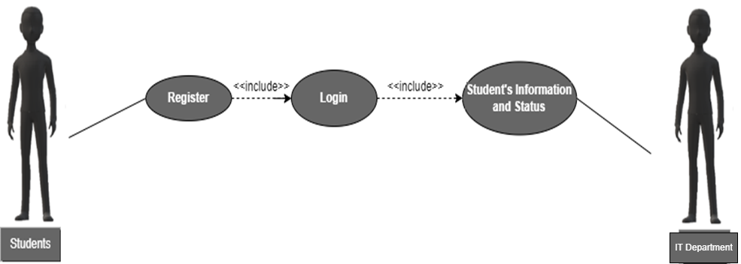

|  |  |  |
| --- | --- | --- |
| **Use Case Name:** | Faculty Manages Student Information (UC-2) | |
| **ID:** | UC-2 | |
| **Actors Involved:** | • Faculty  • IT (Indirect) | |
| **Brief Description** | It describes the process of a faculty member registering, logging in, and managing student information within the attendance system. | |
| **Pre-Conditions** | • The faculty member has internet access and a device to access the system.  • The attendance system software is operational. | |
| **Post-Conditions** | • The faculty member is successfully registered and logged in to the system.  • The faculty member can view and manage student information and status (e.g., attendance records).  • (Indirect) IT retains control over overall system management and security. | |
| **Normal Flow of Events:** | **Actor Action** | **System Response** |
| **1. Faculty:**   * Registers on system page. * Logs in with username/password * Manages student info on faculty dashboard: views lists, individual details, attendance (if permitted), updates (if permitted).  1. **IT(Indirect):**  * IT maintains security, defines permissions. | 1. System creates faculty account securely.  2. Displays student info based on access level.  3. Grants access to a system with valid login.  4. Prompts retry or recovery for invalid credentials. |

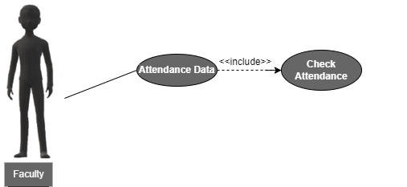

|  |  |  |
| --- | --- | --- |
| **Use Case Name:** | Faculty Checks Attendance (UC-3) | |
| **ID:** | UC-3 | |
| **Actors Involved:** | • Faculty | |
| **Brief Description** | This use case describes the process of a faculty member using the system to view and check student attendance data. | |
| **Pre-Conditions** | • The faculty member is successfully logged in to the system.  • The attendance system has captured student attendance data (e.g., through face recognition). | |
| **Post-Conditions** | • The faculty member has viewed and analyzed student attendance information for a specific class session or timeframe. | |
| **Normal Flow of Events:** | **Actor Action** | **System Response** |
| **Faculty:**  Accesses the attendance data section of the system.  Selects options to view and analyze attendance data for a specific class session, date range, or student. | 1. System displays attendance options.  2. Faculty filter class/date/student.  3. System retrieves attendance info: student list, status (present/absent/late), timestamps. Format depends on system design. |

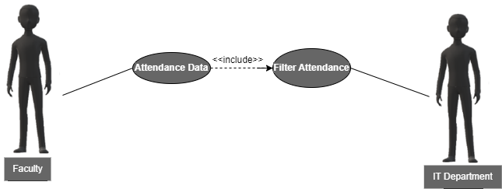

|  |  |  |
| --- | --- | --- |
| **Use Case Name:** | Faculty Filters Attendance Data (UC-4) | |
| **ID:** | UC-4 | |
| **Actors Involved:** | • Faculty  • IT (Indirect) | |
| **Brief Description** | This use case describes the process of a faculty member using the system to filter and view specific student attendance data. | |
| **Pre-Conditions** | • The faculty member is successfully logged in to the system.  • The attendance system has captured student attendance data. | |
| **Post-Conditions** | • The faculty member has viewed and analyzed student attendance information based on applied filters (e.g., date range, specific student). | |
| **Normal Flow of Events:** | **Actor Action** | **System Response** |
| **Faculty:**  Accesses the attendance data section of the system.  Selects options to view and analyze attendance data for a specific class session, date range, or student. | 1. System displays attendance options.  2. Faculty filters class/date/student.  3. System retrieves attendance info: student list, status (present/absent/late), timestamps. Format depends on system design. |

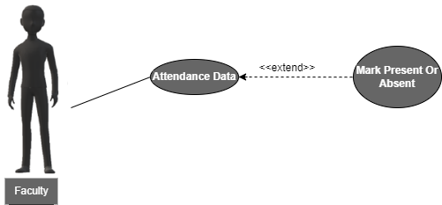

|  |  |  |
| --- | --- | --- |
| **Use Case Name:** | Faculty Initiates Notification to Students (UC-5) | |
| **ID:** | UC-5 | |
| **Actors Involved:** | • Faculty | |
| **Brief Description** | This use case describes the process of a faculty member using the system to mark student attendance during a class session. | |
| **Pre-Conditions** | • The faculty member is successfully logged in to the system.  • The face recognition system is operational. | |
| **Post-Conditions** | • The faculty member also have option to mark (present or absent), if student’s were present in the class.  • The system stores the attendance data for each student. | |
| **Normal Flow of Events:** | **Actor Action** | **System Response** |
| **Faculty Actions:**  • Accesses attendance marking section.  • Selects method to mark attendance:   * Manual selection: Selects attendance status (present/absent) for each student. | 1**. Facial Recognition:**   * Successful recognition marks student "present" with date/time. * Unsuccessful recognition prompts manual selection or retry.   **Manual Selection:**   * Stores faculty's selections for each student's status with date/time. |

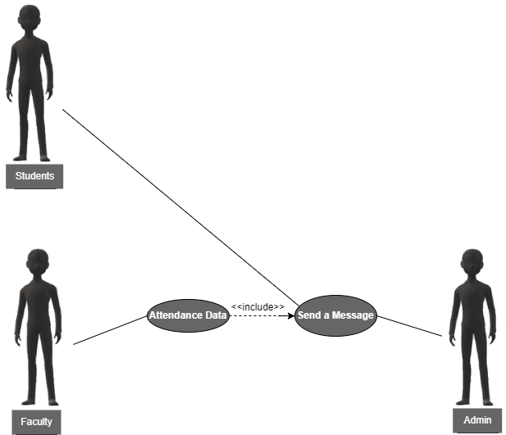

|  |  |  |
| --- | --- | --- |
| **Use Case Name:** | Faculty Initiates Notification to Students (UC-5) | |
| **ID:** | UC-6 | |
| **Actors Involved:** | • Faculty  • IT (Indirect)  • Student (Indirect) | |
| **Brief Description** | This use case describes the process of a faculty member triggering an automated notification system to send messages to students. The IT would have previously configured the system for such notifications. | |
| **Pre-Conditions** | • The faculty member is successfully logged in to the system.  • The attendance system has captured student attendance data. | |
| **Post-Conditions** | • The faculty member has initiated the sending of messages to students based on pre-defined notification criteria (e.g., notifying absent students). | |
| **Normal Flow of Events:** | **Actor Action** | **System Response** |
| **Faculty Actions:**  Accesses attendance data.  Selects options to initiate sending messages to students based on specific criteria (e.g., notifying absent students).  **IT Actions (Indirect):**  Configures the notification system beforehand (templates, recipient criteria).  **Student Actions (Indirect):**  (No direct action) Students receive messages based on pre-configured criteria. | 1. System displays attendance-related options.  2. Faculty selects criteria for sending messages to students.  3. System retrieves relevant attendance data and sends messages based on pre-configured templates. |